The Climb  
  
A Journey of Friendship and Loss

Contents

**Overview** 2

**Product Details** 2

*Players* 2

*Genre* 2

*Platform* 2

*Outlets* 2

**Summary** 2

**Pillars** 2

**Revision History**

|  |  |  |
| --- | --- | --- |
| **Version** | **Date** | **Details** |
| 0.1 | 23.04.2021 | Initial Document |
|  |  |  |
|  |  |  |
|  |  |  |
|  |  |  |
|  |  |  |
|  |  |  |

# Product Overview

## 

## **One Line Summary**

Grief can often change one’s view of reality.

## **Description**

*The Climb* is a first-person climbing game, in which you climb between base camps with your friends on your way up to the top of Everest. 

You must climb ice cliffs and swing between crevasses and hike your way between the base camps, where you take photos of the scenery and your team before resting. 

Along the way, some of your friends disappear from the path. Once you reach the top, you look back on your journey and your photos, and realise only you were climbing all along, and you were climbing for your friends who had died on the mountain in previous climbs.

## **Unique Selling Points**

* Dramatic/Mystery Narrative

## **Target Market**

### **Market Research**

### 1st Person / Platformer

### **Targeted ACB rating**

### PG

### **Targeted Platforms / Outlets**

* PC / Steam, Epic Game Store, Itch

## Persona

## **Competitor Analysis**

## **Design Pillars**

* Mountain Climbing (Anxiety)
  + Using pickaxes to climb sheer mountain walls (Satisfying Mountain Climbing)
* Narrative (Clever)
  + Narration used to tell the journey of the player

# **Mechanics**

* Movement & Look
  + Standard first-person mechanics and mouse to look around
* Dialogue
  + Simple answer and response or scripted dialogue
* Menu
  + Menu will consist of play, exit and gallery of the photos taken
* Interaction
  + Interaction will consist of areas that allow the player to climb, or grapple unto
* Climbing
  + Player can use Pickaxes to climb and traverse areas that are inaccessible through normal means, which consists of sheer ice walls
* Grappling
  + A mechanic that can be used to ‘swing’ over gaps when interactable ice walls are not available
* Camera
  + A mechanic that allows the player to take photos when prompted narratively or at the players convenience. The player can inspect the photo, key photos will change the image to reflect the narrative (images if the friends disappear as the player approaches each level towards the summit)

**Climbing Details**

Description

* Currently, player must press alpha 1 as soon as they begin play for axes to function as intended.
* The player can use their climbing axes to scale climbable walls. They have infinite stamina but must hold onto the wall with at least one hand to prevent them falling.
* On mouse button down hook axe into wall and move towards it.
* Using your seconds axe will override your position.
* Letting go will restore you to your previous axe position.
* On impact with wall, a crack in the ice will form.
* Script Must start disabled.

Details

* Max distance... 2.5
* Speed... 2.5
* Climbing Offset (0, -0.5f, rightHitInfo.normal.z * 0.25f)
* Axe Positions (0.5/-0.5, -0.25, 0.5)

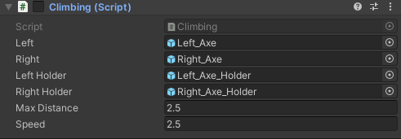

**Grappling Details**

Description

* Press Alpha 2 to equip.
* Player needs a obi collider and obi rigidbody.
* Player must be inside of obi solver (player Container).
* Dangle rope must be child of hand / cube.
* Script Must start disabled.

Details

* Speed is 1.
* Hand Position is (-0.5, 0.25, 0.75)

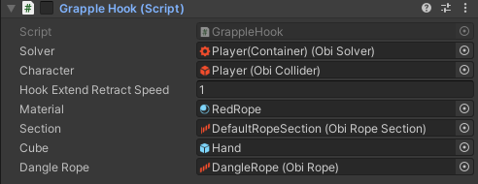

# **Systems**

* Camera Gallery System
  + Allows the player to view the photos taken throughout the journey
* TBD
  + TBD

# **Controls**

# 

* PC
  + WASD for player movement
  + “1” to equip Pickaxes
  + “2” to equip Grappling hook
  + “3” to equip Camera
  + Mouse to look around
  + Left Mouse Button (M1; Left Axe/Interact/Grapple On)
  + Right Mouse Button (M2: Right Axe/Grapple Off)
  + Shift for Run mode
  + Space to Jump

# **Key Characters**

* Player
  + The player takes on the role of the main character taking a journey to the summit of Mt Everest
    - TBD
* Max

**Player Progression**

Mostly demonstrated through new mechanics and story development in the narrative and dialogue

**Level Design**

There are five levels, each representing the stages of grief, the last level us the summit and will not have any other NPC’s, it will only be the player at the end of the game

TBD  
Note: Player will have the ability based on the environment to use both Grappling and Axe to climb up, and to also look behind and use the wall to climb away from gaps to vary the challenge for the player and break up any monotony

* Base of the mountain (Level 1)
  + The beginning level, a tutorial level to induct the player into the primary mechanic and the first NPC will speak from an unreachable distance until the player can start using the Pickaxes
* First Camp (Level 2?)
  + The first cutscene and development of the story

**Themes and Story**

The narrative centres on the theme of the stages of grief and eventual acceptance of loss.

The overall climb for the summit represents going through the path of grief, as you pass the spots where your friends passed away on their attempts to the top.

**The Story**

The story follows the player as they climb to the top, going from camp to camp with their friends and teammates. They use a mix of ice picks, rope swings, and hiking to go from camp to camp, chatting with their friends along the way. As they pass certain points on the climb, the player blacks out, and awakes a while later with a teammate dead. As they get closer to the top, these happen more often, and the player begins to think they are causing these deaths.   
But once they reach the top, with only themselves, they look back on their path and their photos of the camp, and realise that all along, only they were climbing, to conquer their grief and in memory of their friends, who had died on previous climbs.

**Art Style and Aesthetic**

* Colour Palette
* Character Art Style
* Lighting
* Particle Effects

**Sound**

* Music
* SFX
  + Foot Snow Crunch (Footsteps should be alternating between two different sounds to create an emersive sense of motion)